Tesed with SU 8 through SU 2019



sketchup-bridge  
<https://github.com/Aerilius/sketchup-bridge>

eneroth solid tools  
<https://github.com/Eneroth3/eneroth-solid-tools>

improved eneroth solid tools  
<https://github.com/LuluWalls/Improved-Eneroth-Solid-Tools>

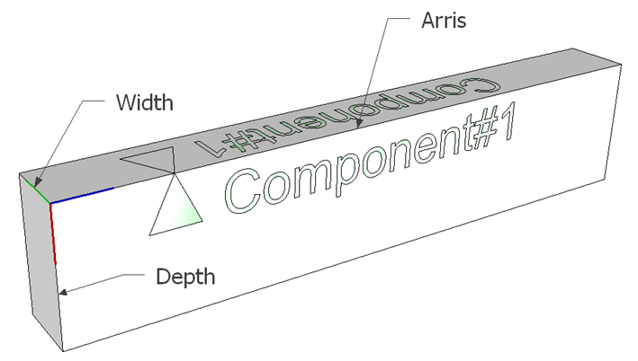

Add Timber Tool



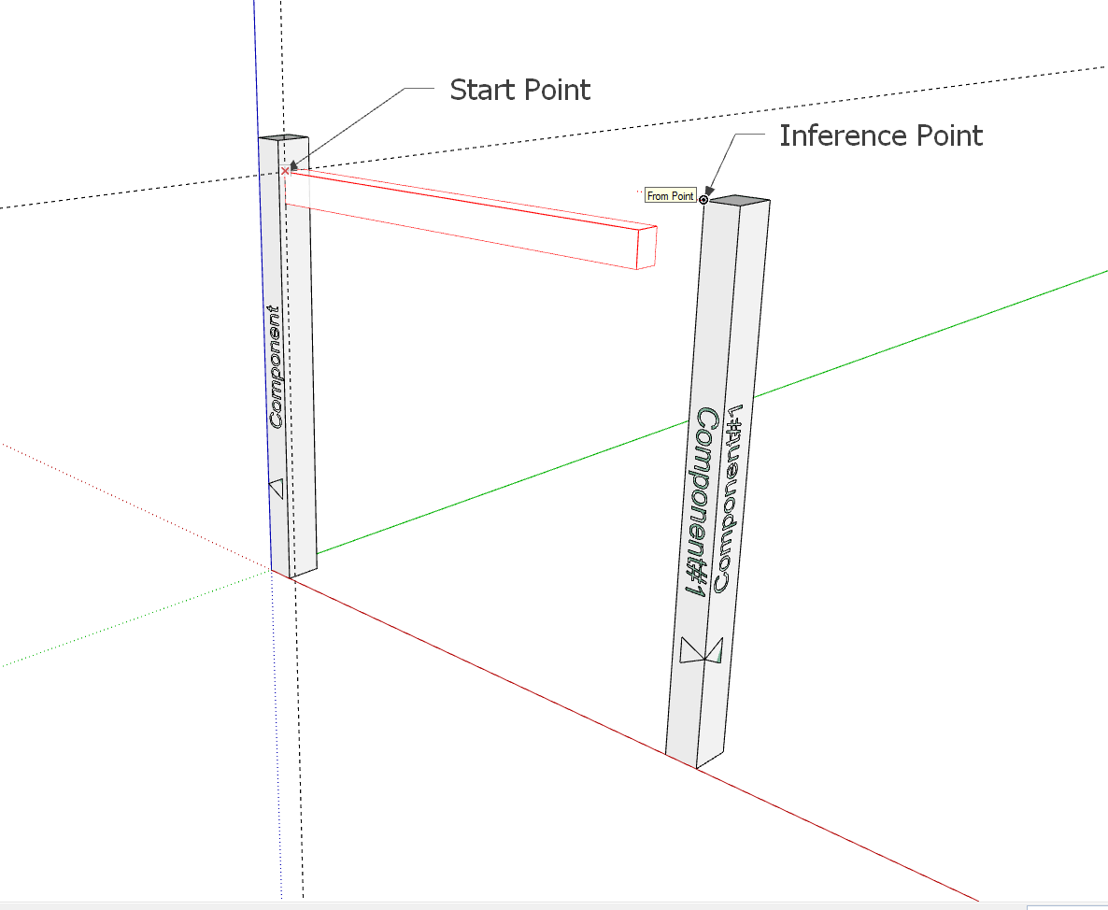







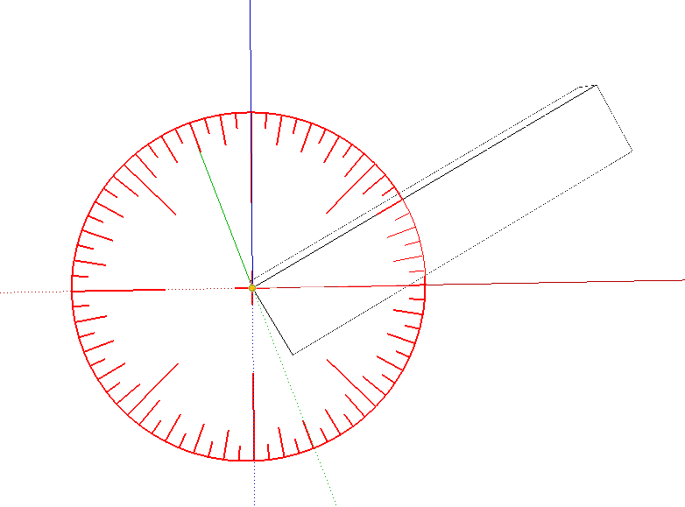

Preferences and Settings



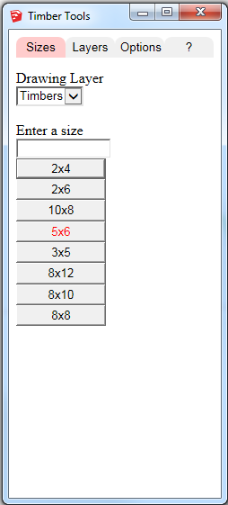

Rotated Timber Tool



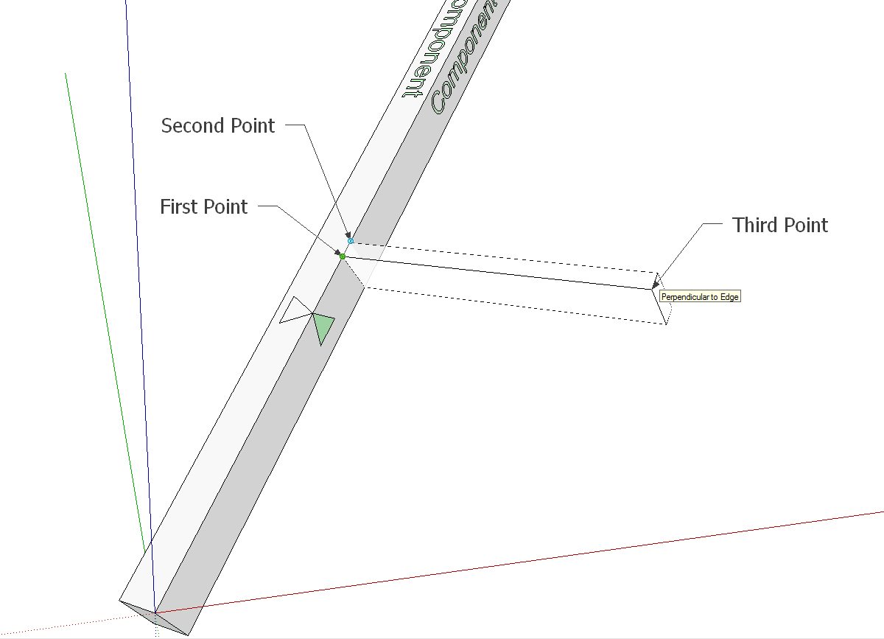

Subtract Tool

